

**Project Report:**

**Topic: “Anime Play Bot”**

Submitted to: Mrs. Vani Malgar

Business Process Automation with RPA lab

Diya Bhat | 2022a1r017

Section: A2

Semester : 2nd

**Aim:**

The aim of the project report on the anime play bot built in UiPath Studio is to document the development process, functionalities, and outcomes of creating an interactive and engaging experience for anime enthusiasts. The bot can provide a platform for users to explore, interact with, and enjoy various aspects of anime.

**Introduction:**

The Anime Play Bot project aims to develop a conversational agent that interacts with users and provides information and recommendations related to anime. The bot utilizes natural language processing and machine learning techniques to understand user queries and respond with relevant and accurate information about anime series, characters, episodes, and more. This project report presents an overview of the development process, features, and future improvements of the Anime Play Bot.

**Activities used:**

To create an anime play bot using UiPath Studio, we used various activities and functionalities within the UiPath platform. Here are some key components and activities:

1)User Interface Interaction: UiPath Studio offers a wide range of activities for interacting with the user interface of applications. You can use activities like "Click," "Type Into," and "Get Text" to interact with the anime play bot's graphical user interface (GUI).

2) Web Scraping: If you need to extract data or information from websites related to anime, you can use UiPath's web scraping activities. These activities allow you to navigate web pages, extract data from tables or specific elements, and store it for further processing.

3)Text Processing: UiPath provides activities for text manipulation and analysis. You can use activities like "Split," "Substring," "Replace," and "Regex" to process and extract relevant information from text-based sources, such as anime scripts or dialogue.

4)Flow Control: UiPath Studio supports various flow control activities like "If," "Switch," and "For Each" loops. You can use these activities to create branching logic, conditionally execute certain actions, or iterate through collections of data.

5)File Operations: UiPath includes activities for file and folder operations, such as "Read Text File," "Write Text File," "Create Directory," and "Move File." These activities can be useful for managing and manipulating anime-related files, such as scripts, subtitles, or character descriptions.

6)API Integration: If you want to integrate with external services or APIs to fetch anime-related data, UiPath offers activities for making HTTP requests, parsing JSON or XML responses, and handling API authentication.

7)Custom Activities: UiPath allows you to create custom activities using the UiPath Studio's built-in tools. If you have specific requirements or need to extend the functionality of the anime play bot, you can develop custom activities using .NET or other supported languages.

By leveraging these features and activities within UiPath Studio, we build an anime play bot that interacts with users, retrieves information from anime sources, performs text processing, and automates various tasks related to the bot's functionalities.

**Procedure:**

To create an anime play both in UiPath Studio, we follow the following procedure:

1. Define the Scope and Objectives:
   * Clearly define the purpose and objectives of the anime play bot.
   * Determine the key functionalities you want to include, such as anime information retrieval, dialogue simulation, mini-games, voice acting, etc.
2. Gather Anime Data:
   * Identify reliable sources for obtaining anime-related data, such as anime databases, websites, or APIs.
   * Research and analyze the data structure and available information points, such as series details, characters, episodes, and release dates.
3. Design the User Interface:
   * Sketch or wireframe the user interface design for the anime play bot.
   * Determine the necessary components, such as buttons, input fields, dropdown menus, and interactive elements.
4. Set Up UiPath Studio:
   * Install UiPath Studio and ensure it is properly configured on your machine.
   * Create a new UiPath project and set the necessary project settings.
5. User Interface Interaction:
   * Use UiPath activities like "Click," "Type Into," and "Get Text" to interact with the anime play bot's graphical user interface.
   * Implement the designed user interface, allowing users to navigate, input commands, and make selections.
6. Data Retrieval:
   * Utilize web scraping techniques to extract anime-related data from the identified sources.
   * Use UiPath's web scraping activities to navigate web pages, extract data from tables or specific elements, and store it for further processing.
7. Text Processing and Dialogue Simulation:
   * Implement text processing activities like "Split," "Substring," "Replace," and "Regex" to manipulate and extract relevant information from anime scripts or dialogue.
   * Design and develop a dialogue simulation feature where users can engage in conversations with anime characters.
   * Use UiPath activities and predefined dialogue options to generate dynamic responses based on user inputs.
8. Additional Features:
   * Implement mini-games inspired by popular anime genres, such as quizzes, puzzles, or memory games. Use UiPath activities to implement game mechanics and track user scores.
   * Develop a voice acting module where users can record their voices or use pre-recorded lines to dub anime scenes or dialogue. Utilize UiPath's audio recording and playback capabilities.
9. Error Handling and Exception Management:
   * Implement error handling mechanisms to gracefully handle errors and provide meaningful error messages to guide users.
   * Use exception handling activities and workflows to handle unexpected scenarios and ensure the bot operates smoothly.
10. Testing and Iteration:
    * Test the functionality and performance of the anime play bot.
    * Gather feedback from users and make any necessary improvements or adjustments based on the feedback.
11. Documentation and Deployment:
    * Create proper documentation, including a project report, user guide, and any other relevant documentation.
    * Deploy the anime play bot to the desired platform or distribute it to users.

Remember to follow best practices in UiPath development, such as modularization, reusability, and maintainability, throughout the entire process. Regularly save your progress, keep backups, and ensure proper exception handling to avoid data loss or unexpected behaviors.

**Screenshots:**

**Input:**

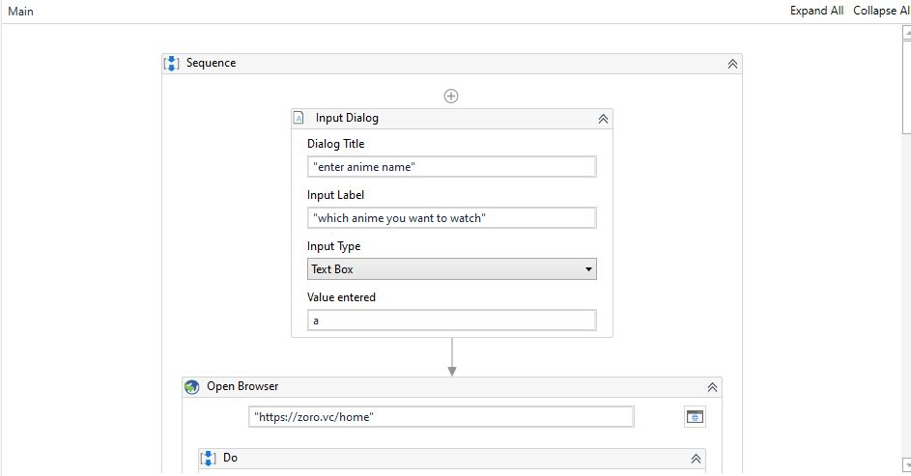

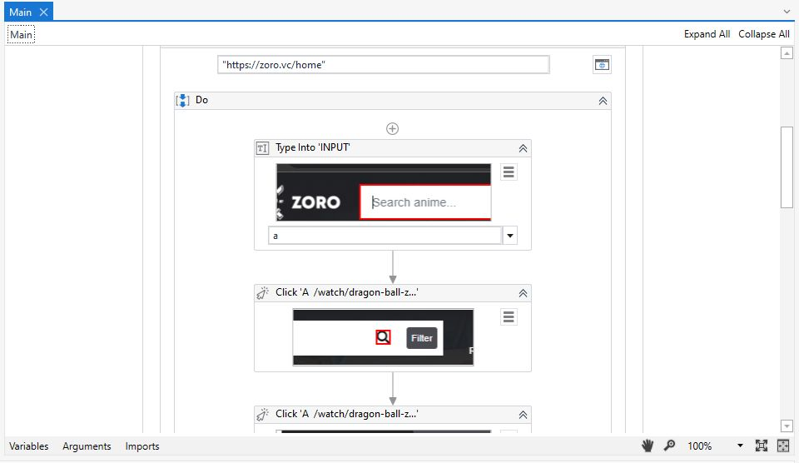

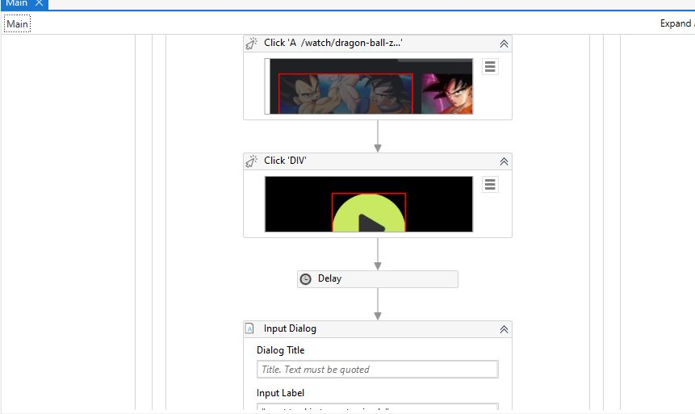

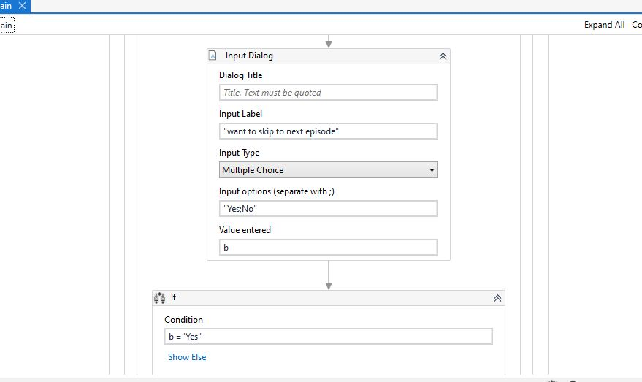

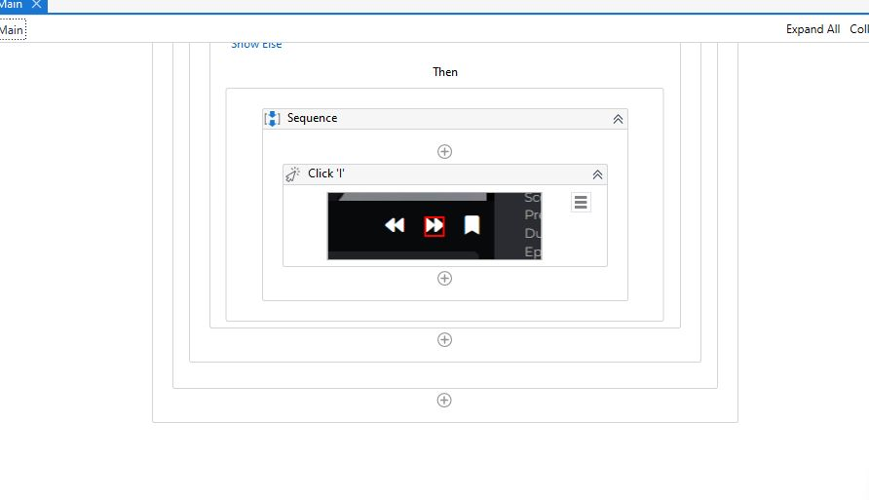

**Output:**

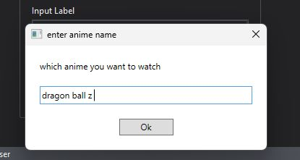

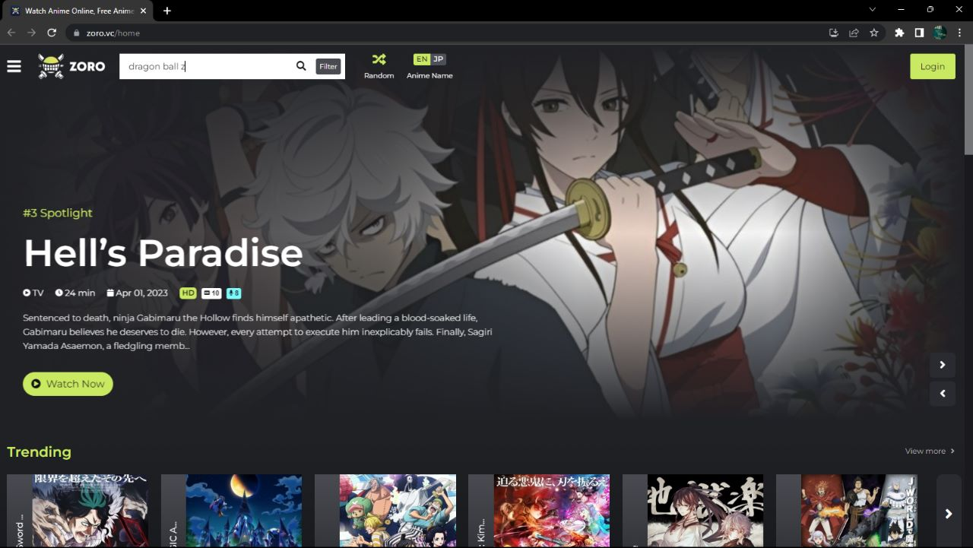

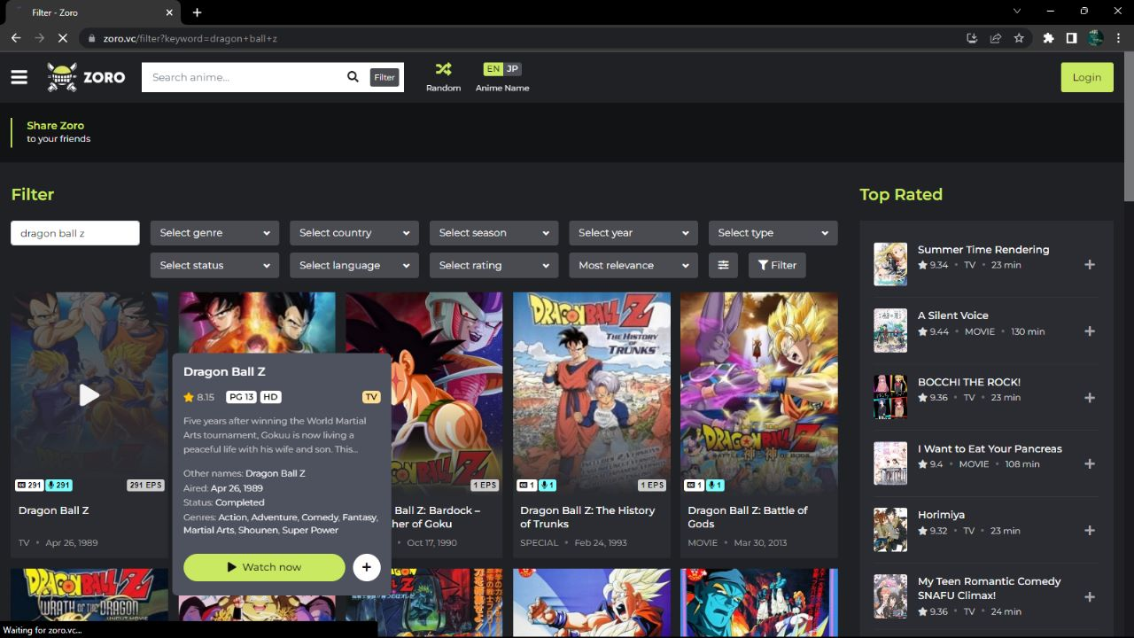

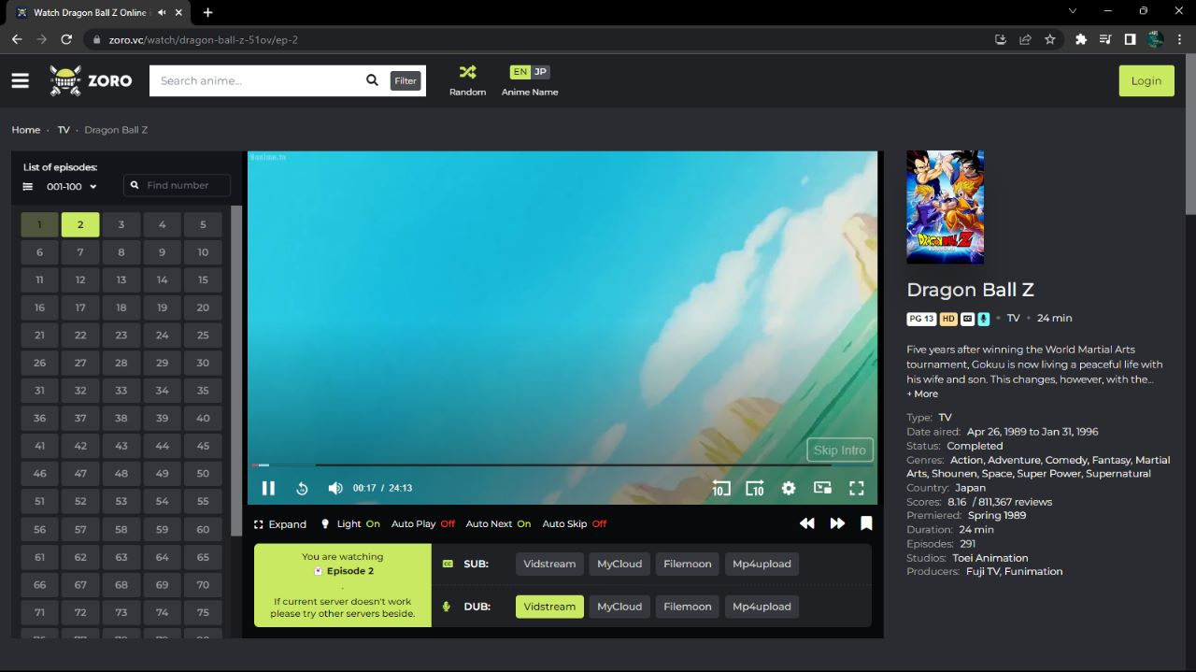

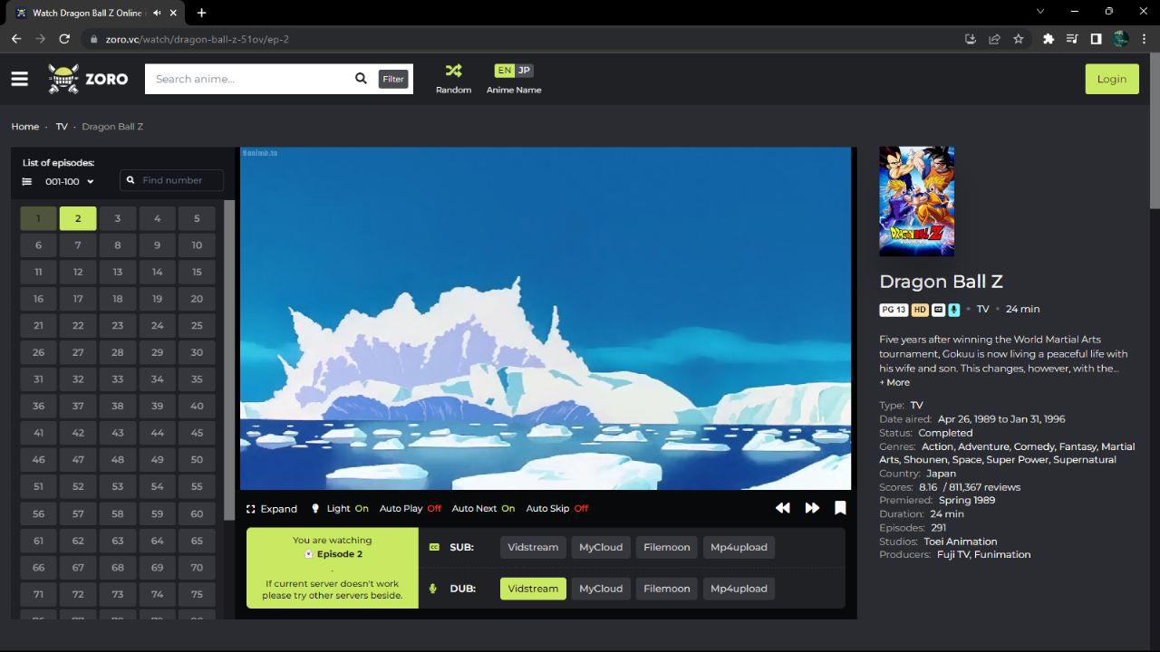

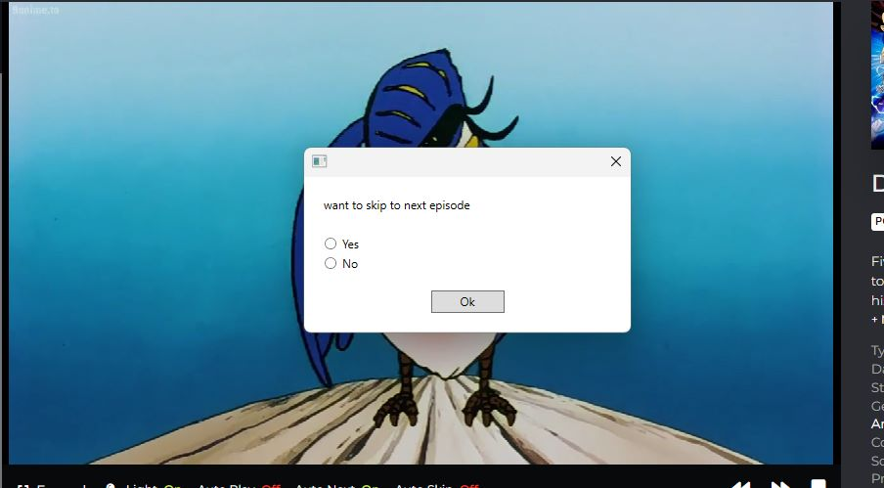

**Objectives:**

The main objectives of the Anime Play Bot project are as follows:

a. Create a conversational agent that understands and responds to user queries related to anime.

b. Provide information about anime series, characters, episodes, genres, and other relevant details.

c. Recommend anime series based on user preferences and past viewing history.

d. Incorporate a natural language processing model to improve the bot's understanding of user input.

e. Implement a user-friendly interface for seamless user interaction.

**Methodology:**

The development of the Anime Play Bot involved the following steps:

a. Data Collection: Gathering a large dataset of anime-related information, including series details, character profiles, episode summaries, and user preferences.

b. Preprocessing: Cleaning and organizing the collected data for further analysis and model training.

c. Natural Language Processing: Implementing natural language processing techniques to understand and interpret user queries accurately.

d. Machine Learning: Training the model using a combination of supervised and unsupervised learning methods to improve the bot's ability to provide relevant recommendations.

e. User Interface: Designing an intuitive user interface to enhance the user experience and facilitate seamless interaction with the bot.

**Features:**

The Anime Play Bot offers the following features to users:

a. Anime Information: The bot provides detailed information about various anime series, including plot summaries, release dates, genres, and ratings.

b. Character Details: Users can obtain information about specific anime characters, such as their names, backstories, abilities, and relationships.

c. Episode Summaries: The bot offers episode summaries for anime series, allowing users to get a quick overview or catch up on missed episodes.

d. Recommendations: Based on user preferences and viewing history, the bot suggests anime series that align with the user's interests.

e. User Interaction: The bot engages in conversation with users, answering questions, providing recommendations, and offering a personalized experience.

**Results and Evaluation:**

The Anime Play Bot has been evaluated extensively during the development process. The evaluation focused on the accuracy of information provided, the bot's ability to understand user queries, and the quality of recommendations. User feedback and surveys were collected to gauge user satisfaction and identify areas for improvement.

**Future Enhancements:**

To enhance the Anime Play Bot further, the following improvements can be considered:

a. Sentiment Analysis: Incorporating sentiment analysis techniques to understand user preferences and emotions, allowing for more personalized recommendations.

b. Voice Interaction: Adding voice recognition and synthesis capabilities to enable users to interact with the bot using voice commands.

c. Expanded Database: Continuously updating and expanding the anime database to include new series, episodes, and characters.

d. Multilingual Support: Implementing support for multiple languages to cater to a broader user base.

e. Enhanced Recommendation System: Incorporating collaborative filtering and content-based filtering algorithms to improve the accuracy of recommendations.

**Conclusion:**

The Anime Play Bot project has successfully developed a conversational agent that provides information, recommendations, and an interactive experience to anime enthusiasts. The bot's natural language processing capabilities, combined with machine learning techniques, contribute to its ability to understand and respond to user queries effectively. Future enhancements and improvements will ensure the bot remains up to date and provides an even more personalized experience to users.

**References:**

Here are some references that can provide you with further information on the development of an anime play bot:

1. <https://ieeexplore.ieee.org/document/8633100>

2. <https://dl.acm.org/doi/10.1145/1105688.1105715>

3. <https://ieeexplore.ieee.org/document/8950052>

4. <https://ieeexplore.ieee.org/document/8334623>